

A

***Project Report***

On

***Airline Reservation system***

For the Course ***(FOP)***

***Fundamental of Program***

Submitted by

|  |  |  |
| --- | --- | --- |
| Name | Reg ID | Degree |
| Aman | 2012375 | BSCS |
| Mohammad Ali | 2012389 | BSCS |
| Hasnain Ali | 2012384 | BSCS |

Submitted to

|  |
| --- |
| *Dr Amir Zeb* |

Submission Date

|  |
| --- |
| *13-01-2021* |

***Content***

|  |  |
| --- | --- |
| *Chapters Name* | *Page No.* |
| Reason to make this program | 2 |
| Project details | 2 |
| Project Working (With Screenshots) | 3-21 |
| Algorithms and Flowcharts | 22-27 |
| Conclusion | 28 |

***Reason to make this Program***

This will save time as it allows online procedure user no longer to wait in a queue to book the flight. using this online system user can easily book a flight from anywhere without facing any problem and also see the info of flight booking. That is why we are developing this airline reservation system which is very helpful for user.

***Project Details***

Airline reservation system will hold flight schedule passenger reservation and ticket record. its saves time as it allows online procedure user no longer to wait in a queue to book the flight.

Firstly, user will select what he/she want. if he/she want to know about flight schedule. or booking a flight. Airline operate flight to 3 destination in Pakistan namely Islamabad, Peshawar, and Lahore. In this process the entire work is done on online. In this system user can see the flight schedule and see their booking as well using code he/she entered. User can also see all the booked tickets of everyone. User will enter the flight number to book the flight where he/she wants to go and then user will select the flight seat in business class, secondary class, economy class. After that the system will show you that your flight booked or not if yes then user will see their payment of flight.

***Working of Project***

#include<stdio.h>

struct info

{

char code[10];

char name[20];

char gender;

char email[200];

char mob[12];

char address[200];

char date[200];

int flight;

char seat;

int price;

}i;

//functions

void booking(void);

void menu(void);

void info(void);

void view(void);

void about(void);

void exi(void);

void key(void);

void main(void){

system("cls");

system("COLOR 8F");

printf("\t\t\t=================================\n");

printf("\t\t\t|| WELCOME TO IISAR AIRLINES:D ||\n");

printf("\t\t\t|| COME FLY WITH US. ||\n");

printf("\t\t\t=================================\n");

printf("\n");

printf("\n");

int chk;

printf("Enter your prefences:\n");

printf("\t\t\t1.Filght Schedule.\n");

printf("\t\t\t2.Book your tickets.\n");

printf("\t\t\t3.Info.\n");

printf("\t\t\t4.View All tickets.\n");

printf("\t\t\t5.About.\n");

printf("\t\t\t6.Exit\n");

scanf("%d",&chk);

switch(chk){

case 1:{

menu();

key();

break;

}

case 2:{

menu();

booking();

key();

break;

}

case 3:{

info();

key();

break;

}

case 4:{

view();

key();

break;

}

case 5:{

about();

break;

}

case 6:{

exi();

break;

}

default:{

int key;

printf("Wrong Input\n");

printf("press any number from 1 to 9 to return to home screen\n");

scanf("%d",&key);

if(key>=0 && key<=9){

main();

}

break;

}

}

}

void menu(void){

printf("====================================================================================================================\n");

printf("|| IISAR AIRLINES ||\n");

printf("||==================================================================================================================\n");

printf("||FLIGHT NO.||DEPARTURE TIME||ARRIVAL TIME||DURATION||DESTINATION||BUSSINESS CLASS||SECONDARY CLASS||ECONOMY CLASS||\n");

printf("||________________________________________________________________________________________________________________||\n");

printf("|| 22201 || 3:00 AM || 4:50 AM ||1hr50min|| KHI-LHR || 12000 rs || 10000 rs || 7000 rs ||\n");

printf("||________________________________________________________________________________________________________________||\n");

printf("|| 11501 || 7:30 AM || 8:25 AM ||1hr55min|| KHI-PSH || 10000 rs || 8000 rs || 6000 rs ||\n");

printf("||________________________________________________________________________________________________________________||\n");

printf("|| 33805 || 1:00 PM || 3:00 PM || 2hr || KHI-ISL || 12500 rs || 10000 rs || 8500 rs ||\n");

printf("====================================================================================================================\n");

}

void booking(void){

char b='b',s='s',e='e';

int amount,j;

FILE *fp;

struct info;

printf("Enter Code(alpha-numeric):");

scanf(" %s",&i.code);

printf("Enter Name(first name only with no spaces):");

scanf(" %s",&i.name);

printf("Enter Gender(M/F):");

scanf(" %c",&i.gender);

printf("Enter your Email Address:");

scanf(" %s",&i.email);

printf("Enter Mobile No.:");

fflush(stdin);

gets(i.mob);

printf("Enter your Address(no spaces):");

scanf(" %s",&i.address);

printf("Enter your date of travel(dd-mm-yy):");

scanf(" %s",&i.date);

printf("Enter Flight No.:");

scanf(" %d",&i.flight);

if(i.flight == 22201){

printf("Enter your Seat \n(B)Buissness class\n(S)Secondary class\n(E)Economy class\n (note: enter small letter)\n");

scanf(" %c",&i.seat);

if(i.seat == b){

i.price=12000;

amount=12000;

}

else if(i.seat == s){

i.price=10000;

amount=10000;

}

else if(i.seat == e){

i.price=7000;

amount=7000;

}

}

else if(i.flight == 11501){

printf("Enter your Seat \n(B)Buissness class\n(S)Secondary class\n(E)Economy class\n (note: enter small letter)\n");

scanf(" %c",&i.seat);

if(i.seat == b){

i.price=10000;

amount=10000;

}

else if(i.seat == s){

i.price=8000;

amount=8000;

}

else if(i.seat == e){

i.price=6000;

amount=6000;

}

}

else if(i.flight == 33805){

printf("Enter your Seat \n(B)Buissness class\n(S)Secondary class\n(E)Economy class\n (note: enter small letter)\n");

scanf(" %c",&i.seat);

if(i.seat == b){

i.price=12500;

amount=12500;

}

else if(i.seat == s){

i.price=10000;

amount=10000;

}

else if(i.seat == e){

i.price=8500;

amount=8500;

}

}

// Saving in file

fp=fopen("booking.txt","a");

if(fp == NULL){

printf("Not Found");

main();

}

else{

fprintf(fp,"%s %s %c %s %s %s %s %d %c %d \n",i.code,i.name,i.gender,i.email,i.mob,i.address,i.date,i.flight,i.seat,i.price);

printf("Congratulation! Booking Successful.Total amount to pay %drs. Have a safe Flight.\n",amount);

}

printf("\n");

fclose(fp);

}

//Printing every record in file

void view(void){

char ch;

FILE *fp;

fp = fopen("booking.txt","r");

if(fp==NULL){

printf("Not found");

main();

}

else

{

while((ch=fgetc(fp))!=EOF)

printf("%c",ch);

}

fclose(fp);

}

void about(void){

system("cls");

printf("People behind the project:\n\n\n \t\t\t-->Capt.Aman-2012375\n\n \t\t\t-->Capt.Hasnain Ali-2012384\n\n \t\t\t-->Manager.Ali Mohammad-2012389\n\n ");

printf("press any number from 1 to 9 to return to home screen\n");

key();

}

void exi(void){

printf("\t\t\t*****************\n");

printf("\t\t\t** **\n");

printf("\t\t\t**Thank You For**\n");

printf("\t\t\t** using our **\n");

printf("\t\t\t** Service **\n");

printf("\t\t\t** **\n");

printf("\t\t\t*****************\n");

}

void key(void){

int key;

printf("Press any Number key:\n");

scanf("%d",&key);

if(key>=0 && key<=999){

main();

}

}

//searching in File

void info(void){

struct info i;

FILE *fp;

char ch[5];

printf("Enter ticket code :");

scanf("%s",&ch);

fp = fopen("booking.txt","r");

if(fp == NULL)

{

printf("file does not found !");

main();

}

else

{

while(getc(fp) != EOF)

{

fscanf(fp,"%s %s %c %s %s %s %s %d %c %d",&i.code,&i.name,&i.gender,&i.email,&i.mob,&i.address,&i.date,&i.flight,&i.seat,&i.price);

if(strcmp((ch),i.code)==0)

{

printf("%s %s %c %s %s %s %d %c %d\n",i.code,i.name,i.gender,i.email,i.mob,i.date,i.flight,i.seat);

printf("\n Record Found\n");

printf("\n\t\tTicket Code : %s",i.code);

printf("\n\t\tName : %s",i.name);

printf("\n\t\tGender : %c",i.gender);

printf("\n\t\tEmail : %s",i.email);

printf("\n\t\tMobile No.: %s",i.mob);

printf("\n\t\tDate : %s",i.date);

printf("\n\t\tFlight No. : %d",i.flight);

printf("\n\t\tSeat : %c",i.seat);

printf("\n\t\tAmount: %d\n",i.price);

break;

}

}

}

fclose(fp);

}

***(Screenshots)***

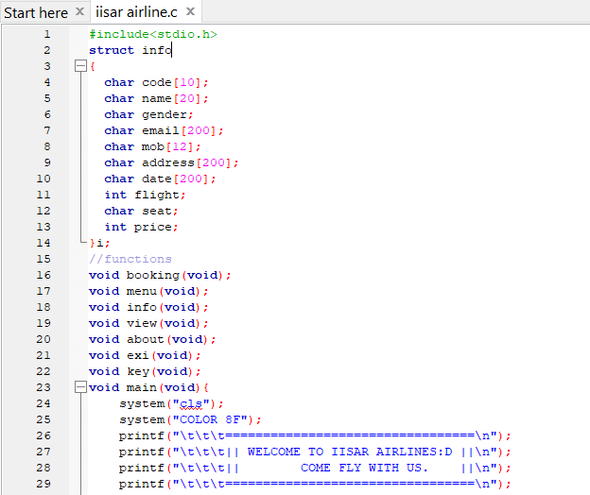

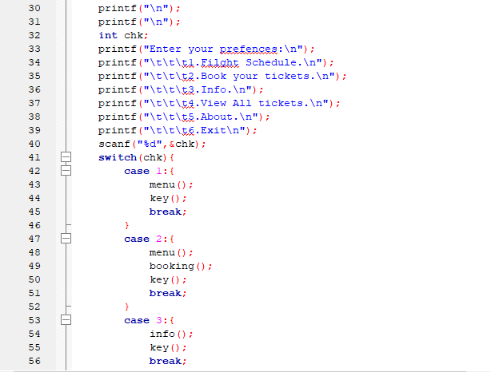

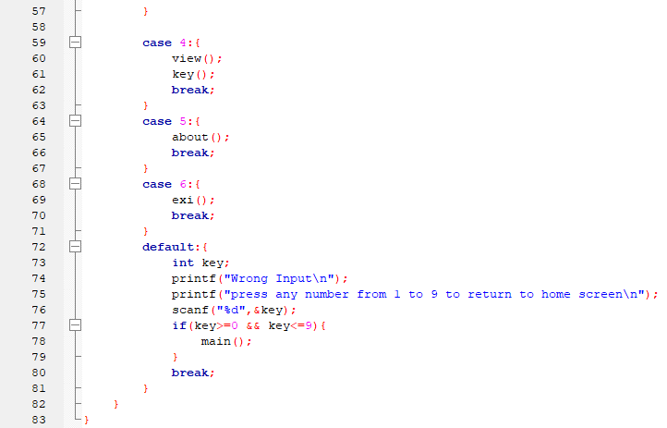

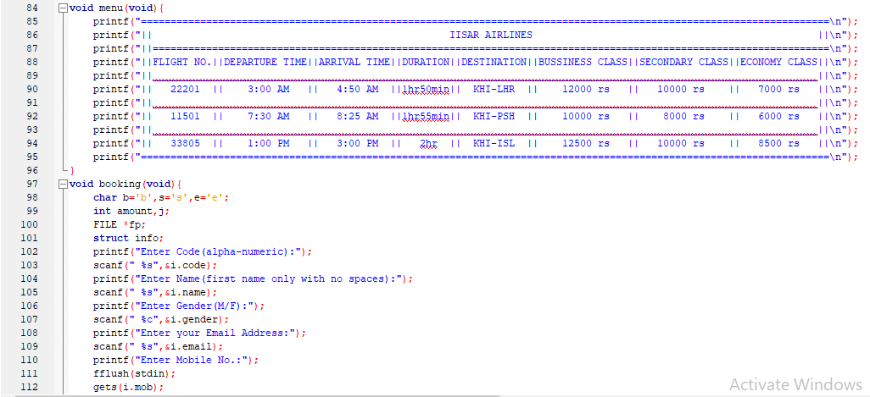

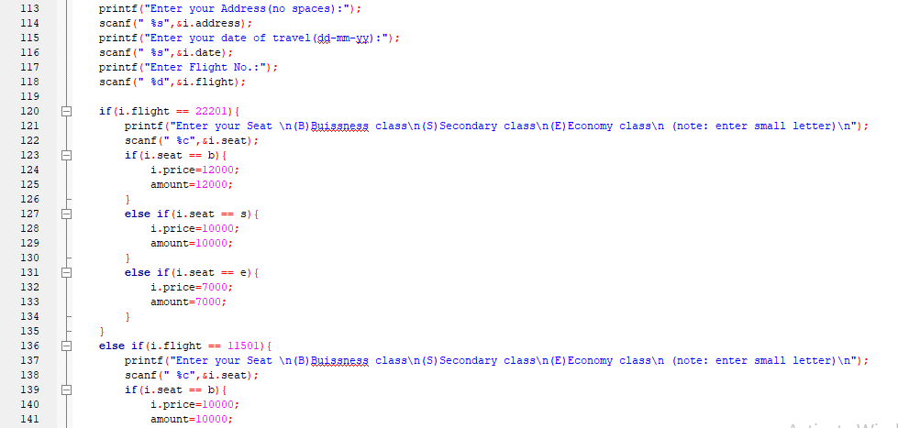

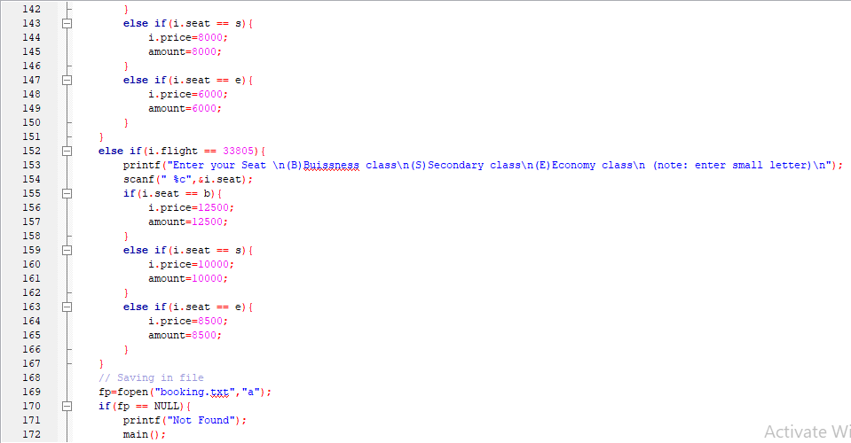

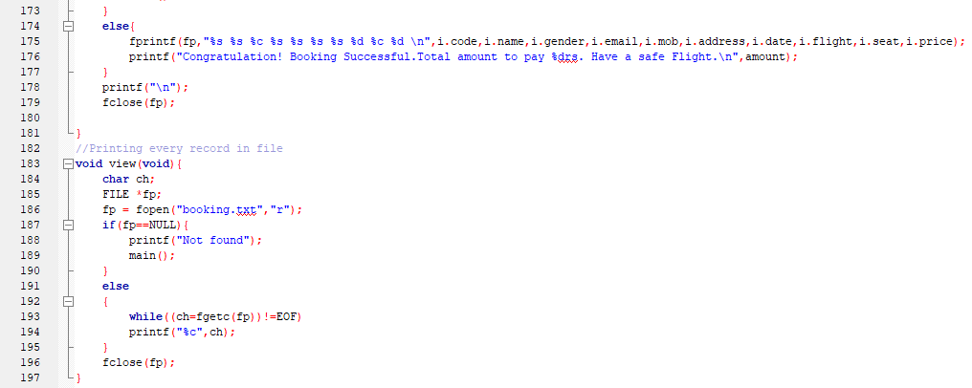



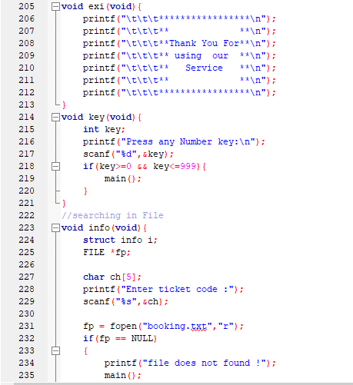

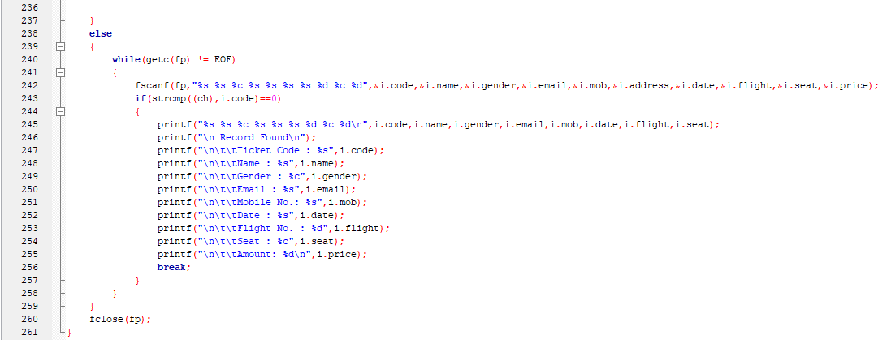

***Outputs***

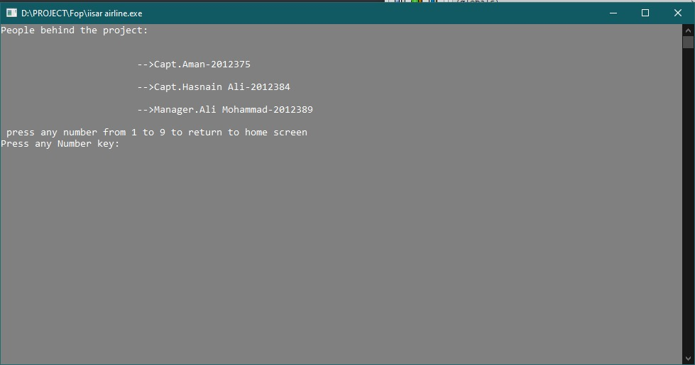

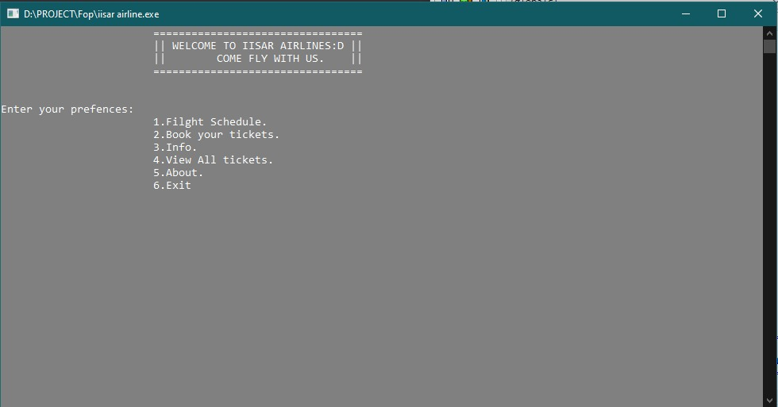

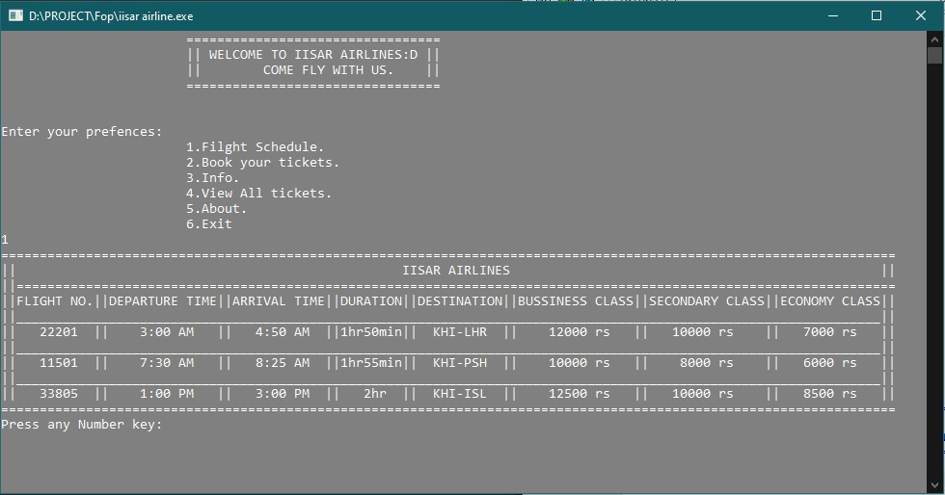

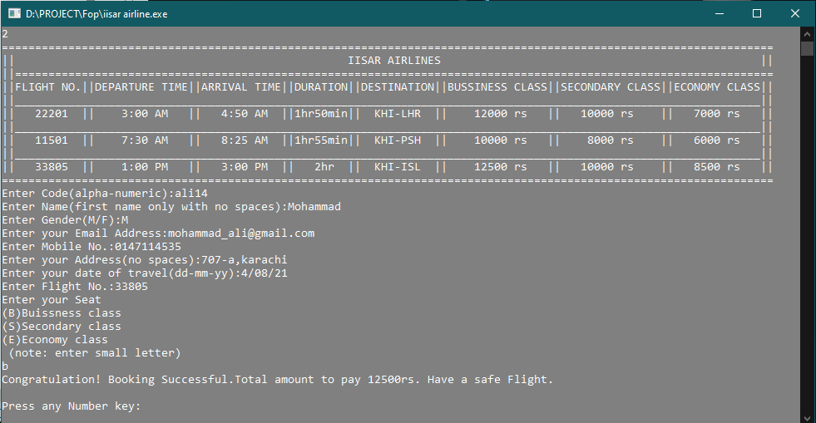

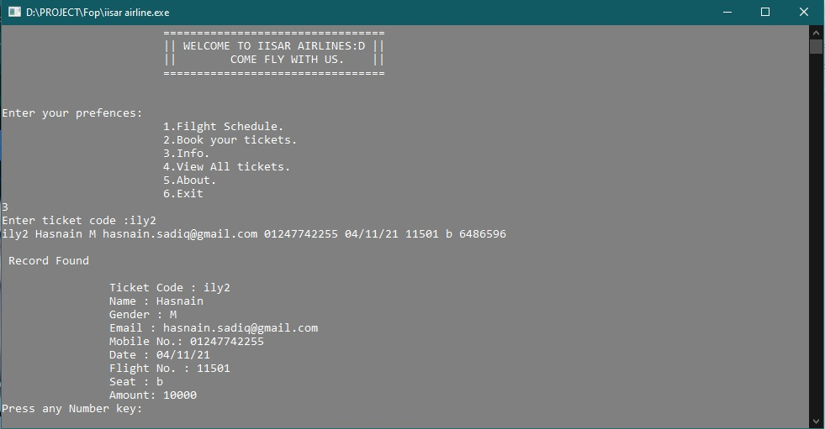

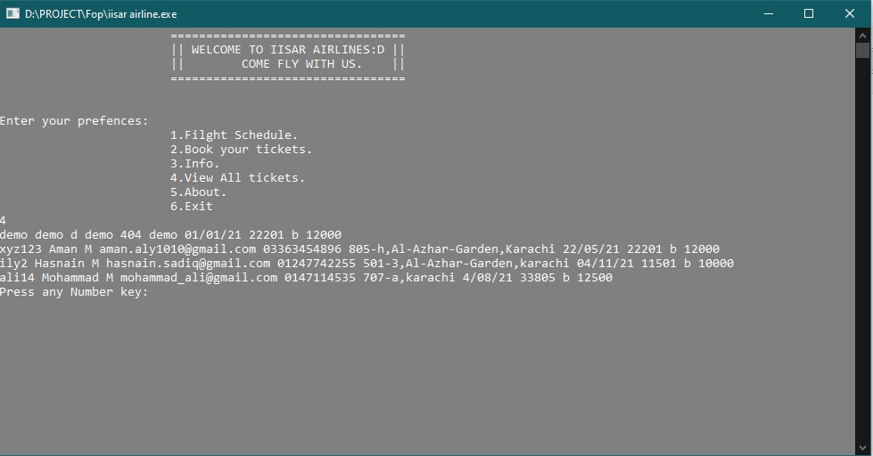

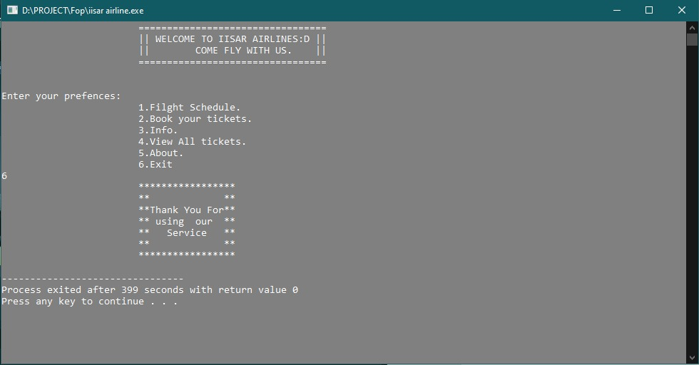

***Algorithm***

1. Start
2. Initialize structure struct info { char code[10] char name[20] char gender char email[200] char mob[12] char address[200] char date[200] int flight char seat int price }i
3. Initialize function void booking(void) void menu(void) void info(void) void view(void) void about(void) void exi(void) void key(void)
4. Initialize function void main(void)
5. Print “WELCOME TO IISAR AIRLINES COME FLY WITH US.”
6. Print “Enter your prefences:”
7. Print “1.Filght Schedule.”
8. Print “2.Book your tickets.”
9. Print “3.Info.”
10. Print “4.View All tickets.”
11. Print “5.About.”
12. Print “6.Exit”
13. Take input chk
14. Switch:
15. case 1:
16. menu()
17. key()
18. break
19. case 2:{
20. menu();
21. booking();
22. key();
23. break;
24. case 3:{
25. info();
26. key();
27. break;
28. case 4:{
29. view();
30. key();
31. break;
32. case 5:{
33. about();
34. break;
35. case 6:{
36. exi();
37. break;
38. default:{
39. int key;
40. print "Wrong Input"
41. print "press any number from 1 to 9 to return to home screen "
42. Take input key
43. if(key>=0 && key<=9){
44. main();
45. break
46. Initializing function void menu(void)
47. Print “IISAR AIRLINES “
48. Print “FLIGHT NO.||DEPARTURE TIME||ARRIVAL TIME||DURATION||DESTINATION||BUSSINESS CLASS||SECONDARY CLASS||ECONOMY CLASS”
49. Print “22201 || 3:00 AM || 4:50 AM ||1hr50min|| KHI-LHR || 12000 rs || 10000 rs || 7000 rs”
50. Print “11501 || 7:30 AM || 8:25 AM ||1hr55min|| KHI-PSH || 10000 rs || 8000 rs || 6000 rs”
51. Print “33805 || 1:00 PM || 3:00 PM || 2hr || KHI-ISL || 12500 rs || 10000 rs || 8500 rs”
52. Initializing function void booking(void)
53. Initializing variable char b='b', s='s', e='e'
54. Initializing variable int amount, j
55. Initializing structure struct info
56. Initializing File FILE *fp
57. Print “Enter Code(alpha-numeric):”
58. Takes input i.code
59. Print “Enter Name(first name only with no spaces):”
60. Takes input i.name
61. Print “Enter Gender(M/F):”
62. Takes input i.gender
63. Print “Enter your Email Address:”
64. Takes input i.email
65. Print “Enter Mobile No.:”
66. Takes input i.mob
67. Print “Enter your Address(no spaces):”
68. Takes input i.address
69. Print “Enter your date of travel(dd-mm-yy):”
70. Takes input i.date
71. Print “Enter Flight No.:”
72. Takes input i.flight
73. if(i.flight == 22201){
74. print "Enter your Seat   
    (B)Buissness class  
    (S)Secondary class  
    (E)Economy class (note: enter small letter)\n");
75. Takes input i.seat
76. if(i.seat == b){
77. i.price=12000;
78. amount=12000;
79. else if(i.seat == s){
80. i.price=10000;
81. amount=10000;
82. else if(i.seat == e){
83. i.price=7000;
84. amount=7000;
85. else if(i.flight == 11501){
86. print "Enter your Seat   
    (B)Buissness class  
    (S)Secondary class  
    (E)Economy class(note: enter small letter)"
87. Takes input i.seat);
88. if(i.seat == b){
89. i.price=10000;
90. amount=10000;
91. else if(i.seat == s){
92. i.price=8000;
93. amount=8000;
94. else if(i.seat == e){
95. i.price=6000;
96. amount=6000;
97. else if(i.flight == 33805){
98. print "Enter your Seat   
    (B)Buissness class  
    (S)Secondary class  
    (E)Economy class (note: enter small letter)\n");
99. Takes input i.seat
100. if(i.seat == b){
101. i.price=12500;
102. amount=12500;
103. else if(i.seat == s){
104. i.price=10000;
105. amount=10000;
106. else if(i.seat == e){
107. i.price=8500;
108. amount=8500;
109. fp=fopen("booking.txt","a")
110. if(fp == NULL){
111. Print "Not Found"
112. main()
113. else{
114. Print in file i.code,i.name,i.gender,i.email,i.mob,i.address,i.date,i.flight,i.seat,i.price
115. Print amount
116. Fclose(fp)
117. Initializing function void view(void)
118. Initializing value char ch
119. Initializing file FILE *fp
120. fp = fopen("booking.txt","r");
121. if(fp==NULL){
122. print "Not found"
123. main()
124. else
125. while((ch=fgetc(fp))!=EOF)
126. Print ch
127. fclose(fp)
128. Initializing function void about(void)
129. Print "People behind the project:   
     -->Capt.Aman-2012375   
     -->Capt.Hasnain Ali-2012384   
     -->Manager.Ali Mohammad-2012389")
130. Print "press any number from 1 to 9 to return to home screen "
131. key();
132. Initializing function void exi(void)
133. Print “ Thanks you for using our service”
134. Initializing function void key(void)
135. Initializing variable int key
136. Print "Press any Number key:"
137. Takes input key
138. if(key>=0 && key<=999){
139. main();}
140. Initializing function void info(void)
141. Initializing structure strcut info i
142. Initializing file FILE*fp
143. Initializing char ch[5]
144. Print "Enter ticket code :"
145. Takes input ch
146. fp = fopen("booking.txt","r");
147. if(fp == NULL)
148. Print "file does not found !"
149. main()
150. else
151. while(getc(fp) != EOF)
152. Takes input in file i.code, i.name, i.gender, i.email, i.mob, i.address, i.date, i.flight, i.seat, i.price
153. if(strcmp((ch),i.code)==0)
154. Print i.code, i.name, i.gender, i.email, i.mob, i.date, i.flight, i.seat
155. Print Record Found
156. Print i.code
157. Print i.name
158. Print i.gender
159. Print i.email
160. Print i.mob
161. Print i.date
162. Print i.flight
163. Print i.seat
164. Print i.price
165. break
166. fclose(fp)

***Flowchart***

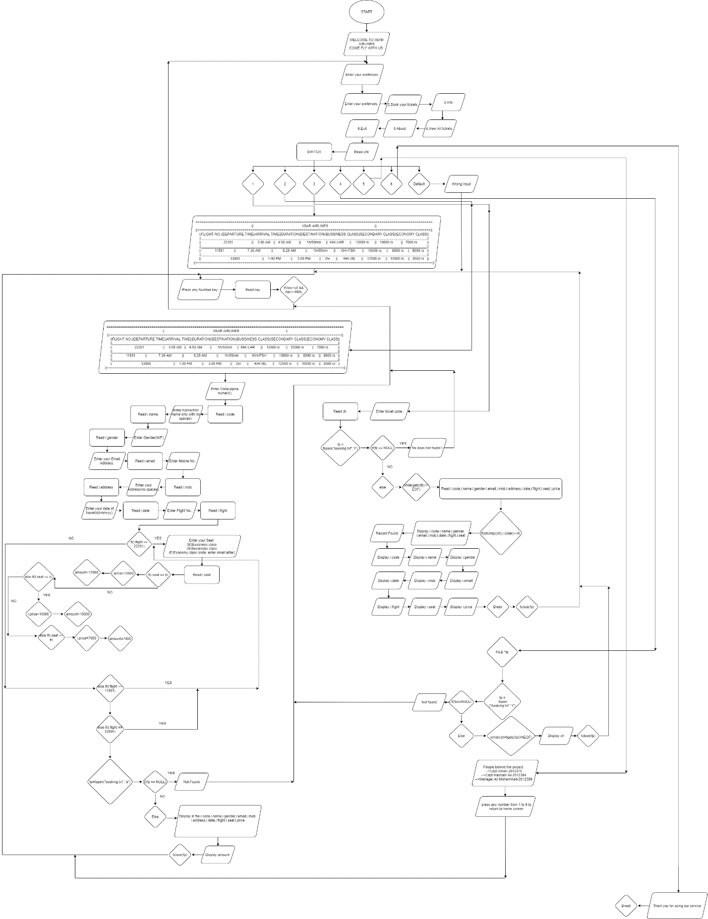

***Conclusion***

The entire project has been developed as per as the requirements stated by the user. The online reservation system enable customer that to check the availability tickets and book their tickets. This makes it easier to sell tickets and book the ticket online.